System Requirements Report

Team Omicron

CE 4000 004

October 19th, 2018

Mitchell Larson

Gunther Huebler

James Windorff

Zachary Oberbroeckling

Brandon Reed

Table of Contents

1. Introduction 4

1.1 System Purpose 4

1.2 System Scope 4

1.3 Definitions, Acronyms, and Abbreviations 4

1.4 References 5

1.5 System Overview 5

2. General System Description 6

2.1 System Context 6

2.2 System Modes and States 7

2.3 Major System Capabilities 8

2.4 Major System Conditions 9

2.5 Major System Constraints 9

2.6 User Characteristics 10

2.7 Assumptions and Dependencies 11

2.8 Operational Scenarios 12

3. System Capabilities, Conditions, and Constraints 12

3.1 Physical 12

3.1.1 Construction and Durability 12

3.1.2 Adaptability 13

3.1.3 Environmental Conditions 14

3.2 System Performance Characteristics 15

3.3 System Security 16

3.4 Information management 17

3.5 System Operations 17

3.5.1 System Human Factors 17

3.5.2 System Maintainability 18

3.5.3 System Reliability 18

3.6 Policy and Regulation 19

3.7 System Life Cycle Sustainment 19

4. System Interfaces 20

4.1 Environment to insole 20

4.2 Mobile Device to User 21

4.3 Server to user 23

# 1. Introduction

## 1.1 System Purpose

LogiSteps is a full stack application that is designed to collect, process, and display user fitness data in a seamless, self-powered construct. LogiSteps allows a user to pair their Bluetooth enabled smart sole with their mobile device and stream data to the cloud in a manner that is unobtrusive and relies very little on the user. By using this system, users can enhance, monitor, and improve their personal fitness without the need of energy demanding equipment that is often bulky and uncomfortable.

## 1.2 System Scope

To satisfy the needs of customers, LogiSteps is scoped to provide data collection abilities that will expose user data using a cloud-based web application. Prior market research and analysis of customer needs identified a need for a wearable device that users could use without constant maintenance and recharging. To solve this, LogiSteps will provide several essential capabilities to make it possible for customers to track personal fitness in an invisible, self-sustaining manner. As a result, the system will use the impact of users’ steps to both collect data and power the system, harvesting raw data in an electronic device embedded into the sole of a shoe. This embedded device will transmit the data it collects to a nearby mobile device, which will then relay the data to a cloud-based web application.

To provide valuable insights into personal fitness, the system will store collected data in a long-term storage medium that will make it possible for performing powerful queries and aggregate calculations that will be served to users through a flexible web-based interface. This enables a user to view their data from any platform, regardless of the device that is used to relay data from the smart sole to the web server. The storage medium chosen will be designed to perform well under a high rate of data insertions and very little deletions. Furthermore, LogiSteps will enable users to closely monitor and track personal fitness progress over long periods of time, helping achieve milestones and fitness goals. While the system is will provide tools for measuring personal fitness, LogiSteps is not meant to, and will not provide medical diagnosis, fitness training, and other high-skill analysis. The physical construction of LogiSteps will be designed to integrate into a user’s shoe with virtually no impact on comfort, allowing customers to setup and ‘forget’ about the device.

## 1.3 Definitions, Acronyms, and Abbreviations

**Piezoelectric** – electricity or electric polarity due to pressure especially in a crystalline substance.

**Bluetooth** – a standard for the short-range wireless interconnection of mobile phones, computers, and other electronic devices.

**BLE** – Bluetooth Low Energy

**Server** – a computer or computer program that manages access to a centralized resource or service in a network.

**Cadence** – the total number of steps you take per minute.

**Wearables** – an item that can be worn.

**AD converter** – A circuit that translates an analog signal into a digital binary format.

**Microcontroller** – A small computer or integrated circuit that contains memory and input/output peripherals.

**Web application** – an application that is stored on a remote server and served to a user over the internet in a web browser.

**Embedded Systems** – A combination of hardware and software designed for a specific application, often small in size.

**e-textiles** – fabrics that enable digital components and electronics to be embedded in them.

**Android** – An open-source operating system for mobile devices.

**Noise** – a summation of unwanted or disturbing energy from natural and sometimes man-made sources.

# 1.4 References

American Chiropractic Association. (2018). *Back Pain Facts and Statistics.* Retrieved from https://www.acatoday.org/Patients/Health-Wellness-Information/Back-Pain-Facts-and-Statistics

Boshell, B. (2017). *Average App File Size: Data for Android and iOS Mobile Apps.* Retrieved from https://sweetpricing.com/blog/2017/02/average-app-file-size/

Lo, K. (2012). *Download Speeds: What do 2G, 3G and 4G actually mean for you?* Retrieved from https://kenstechtips.com/index.php/download-speeds-2g-3g-and-4g-actual-meaning#How_do_the_download_speeds_compare_on_2G_3G_and_4G

Quora. (2018). *What is the distribution of men's shoe sizes?* Retrieved from https://www.quora.com/What-is-the-distribution-of-mens-shoe-sizes

Select USA. (2018). *SOFTWARE AND INFORMATION TECHNOLOGY SPOTLIGHT.* Retrieved from https://www.selectusa.gov/software-and-information-technology-services-industry-united-states

Statista. (2018). *Percentage of the global population that used a mobile app or fitness tracking device to track their health as of 2016, by age.* Retrieved from https://www.statista.com/statistics/742448/global-fitness-tracking-and-technology-by-age/

Verizon. (2013). *4G LTE speeds vs. your home network.* Retrieved from https://www.verizonwireless.com/articles/4g-lte-speeds-vs-your-home-network/

## 1.5 System Overview

In summary, the LogiSteps system will be designed to provide fitness data for health-conscious users wishing to track their data in non-obtrusive, self-sufficient means. The system will be compromised of a smart sole embedded with electronic communication and data collection technology, a mobile device, and a cloud-based web application capable of running across all systems using popular web browsers. This document will layout the black box system requirements for LogiSteps.

# 2. General System Description

## 2.1 System Context

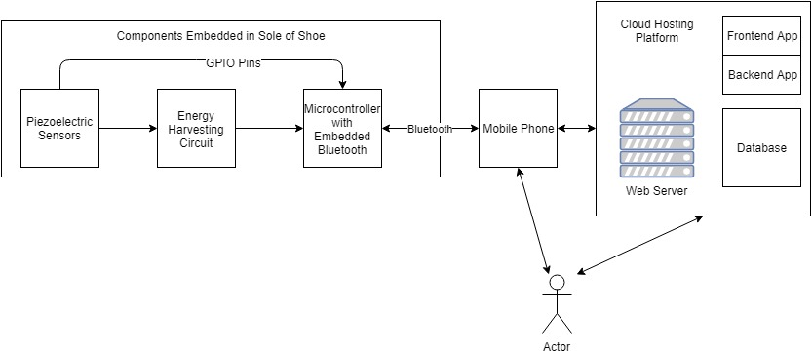

Figure 1 - System architecture of the LogiSteps system. Note the three major components present in the system - Shoe sole, mobile device, and web server.

The proposed system has 7 major components – each with an important role in facilitating data flow from its raw source to the web interface. The system will obtain both data and power using piezoelectric materials that will be embedded into the sole of a user’s shoe. Voltages from the piezoelectric sensors will then provide input to a microcontroller unit and an energy harvesting circuit that is designed to provide a stable power source to the microcontroller unit. The microcontroller unit will use an embedded Bluetooth controller to transmit all data to a nearby mobile device, which will provide a light user interface for the user, and then relay data for long term storage and heavier processing. The web application will then serve a lightweight, but powerful user interface that will provide rich graphics for exploring fitness data.

The LogiSteps system exposes three interfaces that cross system boundaries. These interfaces provide the means for collecting and portraying data to/from external forces and actors. These interfaces include:

1. **Environment to Insole**

The transfer of mechanical energy created from the impact between a user’s shoe and the ground is converted into electrical energy which can be measured and collected. This interface is invisible to the user and requires no interaction other than typical movement.

1. **Mobile Application to User**

Intermediary data, prior to heavy processing, is relayed to the user using a simple user interface native to a mobile device. Additionally, this interface will provide status information regarding connections to the microcontroller unit, and the web server. To initiate these connections, the user interface will provide a means for initiating the connections through Bluetooth pairing and account creation/login.

1. **Web Application to User**

Advanced tables, charts, graphs, and statuses are relayed to the user through a web-based user interface accessible to any device capable of running a web browser. This interface will provide a complex and rich user interaction and can be accessed from any geographical location or technical platform.

## 2.2 System Modes and States

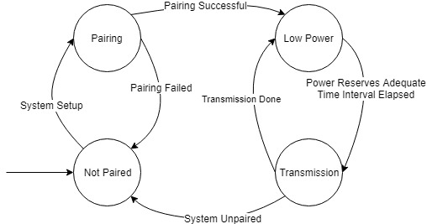

Figure 2 - System states that represent the LogiSteps system.

The system is required to operate under four different states: an unpaired state, a pairing state, a low power state, and transmission state.

When the system is bought, it must be shipped and supplied to customers in the ‘Not Paired’ state. During this state, no collection must occur, and no data transmission must occur. The system should be incapable of performing normal system functions until a user successfully pairs the embedded device with their mobile device.

When a user begins the process of pairing their embedded smart sole with their mobile device, the system should enter a pairing state. In this state, all power must be reserved for the Bluetooth pairing process. Prior to performing this, user’s will be required to walk with their shoes on to build up enough power to perform the Bluetooth intensive task. No data collection or data transmission (other than that required for Bluetooth transmission) should occur when the system is in this state.

During the low power state, the system will minimize the power consumption of essential system functions and shut down any functions that are not critical to system function to save power. Because the system will operate with limited access to power, having a low power state is essential to long term operability. During this state, the system must not perform data transmission, and instead only capture data input as it occurs.

During the transmission state, the system should increase power consumption to transmit collected data points to the paired Bluetooth enabled mobile device. To do so, the system must temporarily supply power to the embedded Bluetooth chip. The system must draw from power reserves built up during the low power state and re-enter the low power state as quickly as possible after data transmission of all data points has occurred. Upon exit of the transmission state, non-essential functions and capabilities will be shut down.

## 2.3 Major System Capabilities

*This subclause should provide diagrams and accompanying narrative to show major capability groupings of the requirements.*

The system needs to be able to gather data pertaining to the user’s activity, store the data permanently, and provide a way of displaying that data to the user in various ways. The system also needs to be robust enough to handle multiple common scenarios the user may be found in and not affect the user’s comfort in any way.

**Physical Capabilities:**

The physical capabilities of the device pertain to concepts such as how the electrical components and sensors are housed, the durability of the insole, and how the insole affects the user’s comfort.

**Form:**

The insole part of the system needs to be a single piece, requiring no assembly, housed entirely in the user’s shoe. There will be no parts of the insole contained outside of the shoe and no parts of the insole crucial to operation that can be removed or broken off under normal conditions.

**Robustness:**

The insole needs to be capable of not being damaged in any way that affects the ability of the system to operate under normal circumstances. Normal circumstances will be discussed in the operational scenarios of this report.

**Comfort Criteria:**

The insole itself needs to not affect the comfort of the user while it is in use. This requires ensuring that the device has a small footprint and be made of a material that is similar to others currently existing in shoe devices.

**Non-Physical Capabilities:**

The non-physical capabilities of the system pertain to the data gathered by the system and the software the user can interact with.

**Data:**

The data will be gathered from the user via a physical device to be worn inside the user’s shoe. This data will be produced while the user takes steps at any rate and relayed wirelessly at all points. The insole will relay the data first to the user’s mobile device, then the mobile device will relay the pressure data from the piezoelectric materials, along with GPS data from the mobile device, to a server for permanent storage and further processing.

**Data Storage:**

The data collected will not require the user to own any other personal storage device nor permanently take up any storage on the user’s mobile device. The data gathered from the insole and relayed to the user’s mobile device will be temporarily stored on the user’s mobile device until connection to the server can be established, at which time the data will be wirelessly offloaded to be permanently stored elsewhere.

**Data presentation:**

The data gathered during operation needs to be made available to the user to view and interact with. A portion of the data will be made available to the user via an application installed on the user’s mobile device and the entirety of the data will be made available via a web application the user can access on any web browsing capable device.

## 2.4 Major System Conditions

The system needs to be able to gather data only in the intended scenarios described in the operational scenarios section. All these scenarios require that the insole part of the system be in the user’s shoe while the user is wearing their shoe and taking steps. During each of these scenarios the insole must be collecting and transmitting data. While the user is not actively producing collectable data (e.g. the insole laying idle somewhere) the system is not required to collect data of any kind.

For data to be relayed from the insole to the user’s mobile device, the insole and the user’s mobile device must be in range to communicate. This range need only be the distance of an average room. While the user’s mobile device and the insole are significantly far apart, data does not need to be collected and may be lost.

For data to be relayed from the user’s mobile device to the server for permanent storage, the user’s mobile device must have an active internet connection. If no internet connection is available, data may be temporarily stored on the user’s mobile device until an internet connection is reestablished.

## 2.5 Major System Constraints

Constraints on the system require that the physical system not be abused in any way. Misusing the insole device may result in decreased operational ability or result in physical system failure. Specific constraints of system operation will be discussed in: section *3 - System Capabilities, Conditions, and Constraints* and section *3.5 - System Operations.*

## 2.6 User Characteristics

LogiSteps is a system targeted towards users who are casually health conscious and wish to gain further insight into data related to their movement. As a result, the system will be designed to meet requirements targeted towards satisfying the needs of this consumer group. There exist other market segment groups which may use the LogiSteps system however, with differing needs and expectations. Each user group may use the system in a different manner, and as a result, they have been recorded. Each group is defined according to their function, location, relative size, and nature of use.

**Casual Health Conscious Users (Target Group)**

* *Function*: Users under this category have average activity rates and health. These users casually track their fitness data using devices like Fitbits and Apple Watches. Precision is not key to these users, but availability and ease of access to data is.
* *Location*: Distribution evenly spread. Climate varies but users do not spend great amounts of time outdoors in harsh conditions.
* *Size*: This is the largest user group who may use LogiSteps (~1/3 of all Americans).
* *Nature of Use:* Users in this category will require that the system can withstand normal walking conditions, and the impact that occurs when walking up and down stairs. These users will occasionally expose their shoes to harsh elements such as rain, snow, and salt, but generally attempt to avoid such conditions. This user group will be primarily interested in step count and calories burned.

**Runners**

* Function: Users under this category have above activity rates. These users typically use wearable technology to track statistics and progress of a run. To these users’ precision and accuracy is usually essential.
* Location: Distribution evenly spread. Climate varies, and users typically spend lots of time outdoors in harsh conditions.
* Size: ~65 million joggers/runners in the United States.
* Nature of Use: Although LogiSteps is not targeted to satisfy all the needs of a runner, many runners may use LogiSteps in place of, or in complement to, other wearable devices.

**Users with Back/Joint Problems**

* Function: Users under this category have back/joint problems, and as a result, closely monitor their posture. Users generally see a certified professional for help improving posture.
* Location: Distribution evenly spread. Climate varies, and users typically spend little time in harsh conditions.
* Size: ~31 million people have back problems in the United States.
* Nature of Use: Although LogiSteps is not scoped to provide medical aid in diagnosing and monitoring posture, users in this group may use LogiSteps in aiding their prognosis of the ailment.

**Tech Enthusiasts**

* Function: Users under this category are excited by new technology and take pride in owning experimental and cutting-edge technology.
* Location: Distribution evenly spread. Climate varies.
* Size: Difficult to estimate quantitatively. ~2 million technology jobs in the US
* Nature of Use: Users in this group will likely use the system sparingly, trying it out for a small amount of time, before focusing on the latest piece of technology.

## 2.7 Assumptions and Dependencies

For successful completion of the system, a few assumptions are made regarding the resources available to the user. The assumptions are made with the thought that they do not provide a difficult barrier to product use and are readily available to all users considering purchase of the LogiSteps system. Additionally, LogiSteps depends on a couple of services from third-party resources to meet the requirements of the system. The assumptions and dependencies that the LogiSteps system will incorporate into design are described in the following list.

**Assumptions**

* Mobile device support/Internet connectivity

The user is assumed to have an android mobile device for phase 1 of the project. Future expansion of the project may include support for additional mobile operating systems/devices. The mobile device must have the ability to access the internet using Wi-Fi or LTE. Additionally, LogiSteps will assume that the mobile device has BLE for communication with the insole.

* Closed toed shoes

LogiSteps assumes that the user has closed-toed shoes, and thus, LogiSteps will not provide, or design for open-toed shoes.

**Dependencies**

* Web Hosting Services

The LogiSteps system will rely on a web hosting service to provide necessary load balancing, scaling, security, and other web-based services that are outside the scope of the project but are a requirement for proper operation.

* Authentication

The LogiSteps system will depend on libraries which belong to the back-end framework for user authentication and authorization.

* Graphics

The LogiSteps system will depend on a third-party library for rendering graphical representation of user data.

## 2.8 Operational Scenarios

Due to the mobile nature of the LogiSteps system, users may experience several different operational scenarios when using the system. To help provide further insight into the requirements and behavior of the system, a few examples are provided below.

**Walking**

As a user begins to walk, the system will begin collecting the energy absorbed by the impact between their foot and the ground. As soon as the system has gathered enough energy, the system will move into its low energy state, continuing to harvest energy, while recording each measurement from the sensors. After the system has acquired enough energy and buffered data for the required amount of time, the system will transmit the data to a nearby mobile device using the BLE protocol. Data will continuously be buffered and sent in this manner periodically. Data will then be buffered on the mobile device, while the mobile device UI is simultaneously updated to reflect the buffered data. Data will finally be sent to a web server for long term storage, where advanced graphics can be viewed.

**Running**

When a user runs, operation will occur in a manner similar to when a user is walking, with one exception. When a user is running, the amount of data being generated by the user (as well as energy) will increase, and as a result, the system may need transmit data at a faster rate to avoid buffer overflow.

**Sitting**

A common scenario that may arise when a customer is using the LogiSteps system is where they are elevated off the ground in a sitting position. In such a situation, little to no pressure will be placed on the insole of the shoe. Such a situation will lead to very little energy generation, as well as very little data collection. As a result, the system will remain in a low energy state until the user begins to behave in a way like the walking and running scenario. In this operational scenario, the system will be mostly idle and attempt to conserve as much energy as possible.

**Standing**

The LogiStep system may exist in a scenario where a user is applying pressure to the insoles of their shoes but remains stationary. Similar to behavior while a user is sitting, very little energy will be generated, and the sensors will not be able to detect steps occurring. When this happens, the system will remain in a low energy state, withholding data transitions until the user begins to move – either walking or running.

# 3. System Capabilities, Conditions, and Constraints

## 3.1 Physical

### 3.1.1 Construction and Durability

Since an important part of LogiSteps is the physical construct of the system, there are a handful of physical conditions and constraints that the system must meet. The physical aspect of LogiSteps includes a shoe insole that measures pressure put on it. Because the insole will be located inside of a shoe, there are various requirements for it to work properly.

**Construction**

The LogiSteps system should be able to support the weight of the average person (around 170 pounds) and has a maximum weight limit of 300 pounds. For the safety of the user and to avoid hardware malfunctions, the LogiSteps system should not expose any electrical components or contacts. To avoid exposed components, all necessary electrical components should be housed inside of the LogiSteps insole. The LogiSteps insole should properly fit inside the size range of adult men’s 8 and above without causing any discomfort to the user. This distribution of shoe sizes should fit most users.

**Durability**

When in use, the LogiSteps insole should run properly in the shoe environment, regardless of any moisture created in the environment. The LogiSteps insole should properly function after going through a cleaning process. This process would consist of lightly wiping with a rag containing cleaning chemicals (e.g. disinfecting wipe). The LogiSteps insole is not guaranteed to properly function after an excessive cleaning process (e.g. submerged in water, washing machine).

**Summary of Requirements**

* + The system must support up to 300 lbs.
  + No electrical components or contacts may be exposed.
  + Components must be housed inside the sole of a shoe.
    - Conditions: LogiSteps must support shoe sizes of Adult 8 (and the women’s equivalent) and up.
  + The system must withstand the moisture created by a user’s foot.
  + The system must withstand the moisture of a cleaning process.
    - Conditions: wiping with rag using cleaning materials
    - Constraint: Not submerged in water (e.g. washing machine)

### 3.1.2 Adaptability

As a physical project, the LogiSteps system should provide adaptability. As a product, the LogiSteps system should provide expansion and growth as new technology is made available, and new user interface features are requested and developed.

**Data processing**

The LogiSteps system should be designed with the ability to expand upon the data processing features. The data collection and transmitting will most likely stay the same, but as LogiSteps enters the market, the system must be developed in a modular approach which allows new data processing features to be easily integrated into the data pipeline. Additionally, the system should be designed to scale up the number of sensors used for data collection and energy generation.

**Mobile devices**

An important aspect of the LogiSteps system is the mobile device interface. Since the LogiSteps system will communicate with a web server using a mobile device, the LogiSteps system should be able to support changes and growth of mobile devices. The LogiSteps system should continue to work properly with mobile devices as long as Bluetooth connections are still enabled and provide backwards compatibility as new operating systems for mobile devices are unrolled.

**Summary of Requirements**

* + The system should support expansion of data processing features.
  + The system should support expansion and enrichment of user experience.
  + The system should support future growth of mobile devices.
  + The system should support changing mobile devices.
  + The system should support the addition of sensors.

### 3.1.3 Environmental Conditions

One of the most important aspects of a physical system is the environmental conditions it can endure. The LogiSteps physical system should be able to withstand all possible conditions that are caused by the environment in which it is used. Because the LogiSteps insole will be placed inside of a shoe, which often encounters harsh conditions, the system must be built to withstand many extreme environmental conditions that most electronic systems are not subject to.

**Pressure**

Since the LogiSteps insole will be put in the user’s shoe, the LogiSteps system must be able to withstand large amounts of pressure. The system must be able to withstand pressure caused by day to day actions of the user (eg. running, jumping, lifting weight, etc.). The system is not guaranteed to work properly when excessive force, such as car accident or high fall, is applied.

**Protection**

Given the environment in which the LogiSteps insole will reside, the system must be able to protect against water and dust. To accomplish this, the system will have an Ingress Protection rating of 67. This means that it will be protected against all solids and will be protected from temporary submersion in water (e.g. stepping in a puddle). It will not be protected against continuous submersion in water.

In addition, the system must be protected against electricity that could be naturally applied to it (e.g. static electricity from friction).

**Temperature**

Given the environment of the LogiSteps insole, the system must also be able to withstand temperature changes caused by the environment. When used outdoors, the LogiSteps system must withstand a wide range of temperatures. The microcontroller has an operating temperature range of –25 to 75 degrees Celsius and the system should function properly in any environment that meets this temperature range. The system should not be guaranteed to work properly when exposed to extreme heat or cold outside of this range.

**Communication**

The LogiSteps system must be able to communicate properly to a mobile device when background noise is present. The system must also ensure that the system is able to properly communicate through the insole material as well as any other obstacles between the LogiSteps system and the mobile device.

**Summary of Requirements**

* + The system must withstand additional impulses and pressure caused by contact between the user and their environment:
    - Conditions: This includes behavior that ranges from typical walking, to running, jumping, and lifting heavy weights.
    - Constraints: The system should not support impacts due to abnormal collisions such as car accidents and high falls.
  + The system must be IP67 rated for water and dust.
  + The system must withstand environmental temperature conditions:
    - Conditions: temperature range (MCU scale: -45-85 degrees Celsius)
  + The system must withstand heat radiated from a user’s foot, as well as heat generated from foot contact with the ground.
  + The system must not be adversely affected by static created when a user’s foot contacts any surface (such as concrete, carpet, and much more).
  + The system must be able to successfully communicate under regular environmental background noise.
  + System communication must be able to permeate through the form factor of a user’s shoe and body and reach a mobile device within 0 and 3 meters of distance.

## 3.2 System Performance Characteristics

There are some expected minimums the LogiSteps system will meet in regard to its performance. It has specific performance requirements for each stage of the system.

**Startup**

When the LogiSteps system begins functioning (when it is turned off and the user begins walking), it is expected that the user will be able to pair the insole to their mobile device and begin receiving their fitness data on that mobile device within thirty seconds. They should also be able to view their processed fitness data on the web application within sixty seconds of beginning usage.

**Post-Startup**

After the LogiSteps insole has gathered enough energy for the initial pairing with the user’s device, and has paired with the user's device, it has entered its post-startup stage. In the post-startup it is expected that the user will be able to view all of their basic data gathered from the insole on their mobile application in real time. And they will be able to view all processed data from the insole on the web application within sixty seconds of seeing it on their mobile device. It is also expected that the insole will gather and transmit user fitness data at a consistent rate, regardless of the user’s cadence. That is, no matter how slowly or quickly the user moves, the system will gather all pertinent fitness data from their movements. This of course makes the assumption that the user's cadence will fall into a normal human's range that can be expected in the day to day activities of a casual user, or the heightened activities of a serious user.

**Lifetime**

Regarding the LogiSteps system lifetime there are some expectations as to how long the insole should last. As the insole will be put into a user’s shoe, and always kept in their shoe, the system is expected to last a minimum of 1 year.

## 3.3 System Security

As the LogiSteps system will require pairing with a user's mobile device, the transmission of user data over the internet, and the storage of user data on the cloud, there are several considerations that have to be made for LogiSteps security. The security required can be looked at for each individual stage of the system.

**Insole to Mobile Device**

Neither the LogiSteps embedded system in the insole, or the wireless transmission from the insole to the user's mobile device will have to be secured in any way. This is due to the fact that all of the information that will be on the embedded system, and transmitted over Bluetooth, will contain no confidential information. It will consist solely of raw sensor data, and the associated time data.

**Mobile Application to Cloud**

The LogiSteps mobile application on the user’s mobile device will require some security to ensure only the correct user can connect to their insole, and to the cloud. To achieve this, the mobile application must implement login functionality to ensure the user’s data on the mobile application can only be accessed by the correct user. This login functionality will also be used in the connection to the cloud to provide user authorization to send and receive data from the mobile application. Because data transmitted from users’ mobile device will contain sensitive GPS data, the connection between the mobile application and the cloud must be secured using HTTPS.

**Cloud Web Application**

LogiSteps data will be stored on a server on the cloud. As this data will contain personal and confidential user information, the web server must implement proper security protocols to ensure all user data contained within it will be protected from hacking attempts and data stealing. Also, for the user to access their data on the web application, login functionality will be used again to enforce user authentication to access their data stored on the web server. The web application will also ensure a secure connection between itself and the user using HTTPS. Additionally, the web application must keep all data used for global statistical analysis anonymous to other users.

## 3.4 Information management

LogiSteps is a data driven application that will acquire large amounts of user data, which will increase proportionally with both time and the number of users using the system. To ensure that the system can provide the necessary capabilities to users, while responsibly and safely storing data, the following requirements have been drafted. The LogiSteps system must be designed to meet the following information management requirements.

* Users must have access to their data through the user of interactive graphical user interfaces
* User data must not be sold or given to any third party without the express written consent of the effected user.
* The system must store data for long-term retrieval and statistical analysis on a database decoupled from the user's mobile device
* The system must initially support up to 6 months of user data and provide means for scaling up the amount of stored user data for future expansion.
* The system should allow users to permanently delete their connection to their data, while maintaining the data in an anonymous format for aggregation of global data.
* The storage medium used for long-term storage must be capable of scaling well with time and users.
* The system should delete all user data off mobile devices upon deletion of the mobile application.
* User data used for aggregate global analysis must be anonymized to protect users’ identities.
* If a connection cannot be established, or a connection is dropped between the insole and a user’s mobile phone, data should be discarded upon attempted transmission.
* If a connection cannot be established, or a connection is dropped between a user’s mobile phone and the remote web-server, a circular buffer of 20 MB should be established, and data should be temporarily held on the mobile device until it can be successfully offloaded to the server.

## 3.5 System Operations

### 3.5.1 System Human Factors

Because part of the LogiSteps system is the physical insole, the insole must be sensitive to human factors and limitations. Ultimately, the LogiSteps insole must be able to properly read and create data based on the pressure applied within the capabilities of a human. The LogiSteps insole system must be able to detect when small amounts of pressure are applied and will be able to differentiate between the pressure of an average step and small amounts applied naturally without taking a step.

**Durability**

The LogiSteps system must be durable enough to withstand pressure that is naturally applied to it in a natural setting. The LogiSteps insole must be able to withstand the pressure caused by day to day activities that are performed by the user, such as running, walking, jumping, and heavy lifting. The LogiSteps system should not be guaranteed to withstand any pressure caused outside of human capabilities.

In addition, the LogiSteps insole system must withstand any bending that is applied to it within its natural environment. The LogiSteps insole will be designed to withstand any bending as a result of force applied by the human foot. The LogiSteps insole should not be guaranteed to withstand any bending caused by excessive forces beyond the human capability.

**Summary of Requirements**

* + The system must sustain operation under the pressure generated from a user’s step under reasonable conditions
    - Conditions: Running, walking, heavy lifting, etc.
    - Constraints: Applying excessive force (running over with car, smashing with something, etc.)
  + Must be able to handle any bends that are a consequence of human foot flexibility

### 3.5.2 System Maintainability

LogiSteps must be a self-sustaining system. The hardware should be encased so that the user is not able to change any of it. The solution to hardware failure will require changing out the component. The hardware will be expected to last a minimum of one year.

The only maintenance required by the user should be the connections between pieces of hardware. The user must be able to disconnect and re-establish Bluetooth connection to the insole from the user's mobile device. This should only be required in worst case failures or change in hardware.

The mobile application will have the potential for updates and for preventative maintenance. As the product gains popularity, it is possible that flaws in the software may be discovered. This should be monitored on a weekly basis and if updated if required.

### 3.5.3 System Reliability

LogiSteps has multiple systems within itself that make up the whole. The reliability of the system is dependent on the parts being reliable. The system must maintain data transfer from the insole to the web server with an uptime greater than 99%.

**Server**

The server must have an uptime greater than 99%. This will allow the mobile app to not have to store a lot of data on itself. The use of a cloud based web-server should prevent the user from noticing any substantial slowdown of their mobile device.

**Mobile app**

The mobile app will have a Bluetooth connection that will be required to communicate with devices between zero and three meters of the user. BLE supports a maximum range of one-hundred meters when operating under full power. Due to the low power requirements of the LogiSteps system, a maximum Bluetooth range of 100 meters will not be supported.

The second part of the mobile app is the connection to the server. The connection to the server must be available if the user is connected to their Wi-Fi or LTE network with an uptime greater than 99% in order to ensure a seamless user experience and reduce the amount of data that will need to be cached on a user’s mobile device.

## 3.6 Policy and Regulation

LogiSteps has defined two major policy and regulation requirements to ensure that the system meets the needs of its users and fulfills ethical design requirements.

**Health and Safety**

LogiSteps must ensure that any user of the LogiSteps system will not suffer any adverse physical affects due to the LogiSteps system. The LogiSteps system should be non-flammable and its electrical components should be unable to harm the user in any way. The insole should also be made of a safe material to ensure users will not suffer from adverse effects such as allergic reactions, rashes, etc.

**User Data**

The user’s data must, first and foremost, be safe and secure wherever it is stored, or transmitted. The requirements to satisfy this have already been defined in sections *3.3* and *3.4* of this system requirements report. The user data will, however, be owned by LogiSteps. This data will not be sold or given to any third party without user consent. Should the user wish to delete their account and associated data, all personally identifiable and confidential data associated with that user will be permanently deleted and removed from the LogiSteps servers; the data however, will continue to reside on LogiSteps servers to provide global analytics and aggregate calculations.

## 3.7 System Life Cycle Sustainment

In terms of system life cycle sustainment, the LogiSteps system must plan for sustainment before release as well as provide continuous sustainment after being released.

**Prior to release:**  
In planning the LogiSteps system, Team Omicron must plan for the system to be updated on a regular basis. The main form of updates for the system will be updates to the user interface. To accomplish this, the user interface design must plan for continuous updating and should be able to be updated without causing errors.

Also prior to release, field testing must be done to ensure proper operation of the LogiSteps system. Through testing of the system, issues can be found and resolved before finalizing the system design and operation.

**Ongoing:**

In providing ongoing life cycle sustainment, the LogiSteps system must be able to ensure proper operation. The system must be able to detect any anomalies with data and provide solutions to fixing the data. The software will be updated in the case of any bugs or hardware will be replaced if not functioning properly.

In addition, user feedback will be an important aspect of ongoing sustainment. The LogiSteps user interface and software should be continuously updated to provide users with requested features and bug fixes, and a conduit for submitting user feedback should be established.

# 4. System Interfaces

## 4.1 Environment to insole

The way the environment interacts with the sensors needs to be carefully considered. The energy produced by the piezoelectric sensors needs to be great enough to power the electrical components inside of the insole device. For piezoelectric material to produce energy it needs to be deformed, and this deformation will be caused by the intended environment.

**Definition of Intended Environment:**

The intended environment is the area immediately surrounding the insole while the system is in use: the sole of the shoe and the user’s foot. When a user takes a step, their foot applies downward pressure, compressing the insole in the direction of the sole of the shoe.

**Capability:**

The interaction between the environment and the insole needs to be capable of producing enough energy to power the electrical components within the shoe. This energy is created by a deformation of the piezoelectric sensors embedded in the insole and this deformation will be caused by the design of the insole.

**Condition:**

This interaction need only meet requirements while the insole is within the intended environment. It is not required that the insole interact with any other environment enough to power any component. However, the insole will still be capable of working outside of the intended environment if the user wishes to simulate footsteps for testing/troubleshooting.

**Constraints:**

The intended environment must not be capable of producing any amount of stress to the insole that would cause damage to the hardware housed inside. This involves ensuring that the user cannot apply too much pressure during normal activities.

**Future Modifications:**

The interface between the environment and the insole must have room for improvement in the future. The insole part of the system is very dependent on low power consumption of the electrical components, limiting the choices for insole hardware and software features. This creates a significant demand for the ability to harvest as much power as possible, since doing so will allow for as many hardware and software options as possible: electrical components with a higher energy demand can be considered, transmitting data at higher rates becomes an option, and more powerful real time processing can be done inside the insole itself rather than the mobile device or server. Because of this, optimizations to sensor activating techniques need to be explored in the future as new technology is developed.

## 4.2 Mobile Device to User

The next major system interface is the mobile device app. There are three aspects to the mobile device app: the Bluetooth to the insoles, the data connection to the server, and the user interface. The three are the middle point to the system as a whole to bus data between the devices. The Bluetooth connection should transfer data from the LogiSteps device to the mobile app at an optimal speed of 100kb/s with a maximum of 1Mb/s. The maximum is the maximum speed that Bluetooth Low Energy can achieve, while the optimal is dependent on how large the data is that is collected from the insole. Additionally, the mobile app must show the user real time data that the mobile device has temporarily stored as it prepares to send it to the server. The mobile app will move the data at an optimal speed of 1Mb/s to the server with a maximum of 12Mb/s and a minimum of 300 kb/s. The maximum and minimum are dependent on the mobile device’s LTE network where the optimal is for burst sending data from the mobile device. This is required to save the user’s data so LogiSteps does not need a constant connection and consume unnecessary amounts of data.

The user interface should have two screens - the log in screen and the summary view. The log in screen is very basic. LogiSteps allows must provide a conduit for a user to log in through Facebook and Google if they choose, or, they should be able to create an account through LogiSteps’ services.

**Basic View Interface Requirements:**

* View step count.
* View a step projection for the day.
* Connect and disconnect from the insoles individually.
* View steps in the past hour.
* Show the Bluetooth status for each insole.
* Show the status of the connection to the server.
* Show a projection of steps for the day.
* Show a user defined step goal.
* Main screen is one page without scrolling

**Login Screen**

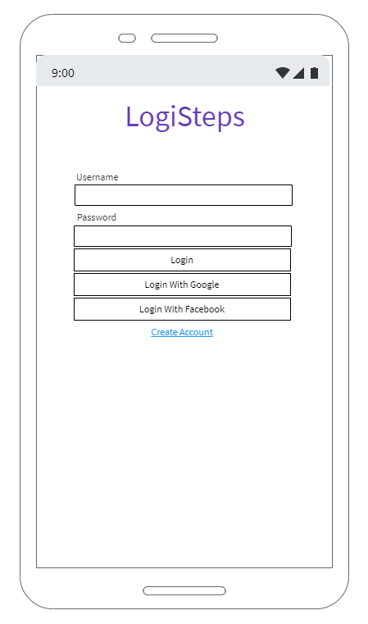

Figure 3 - Initial mockup demonstrating system requirements for a log on screen on the system's mobile device.

The login screen should be a basic screen. The authentication with the username and password fields should be managed by the LogiSteps system, and if the user chooses, they should be capable of logging in using services such as Facebook or Google by clicking their corresponding button. The create account link should not change the layout and instead act as an alternate to the login button. It should take what is in the username and password field and create an account using the entered information.

**Main Screen**

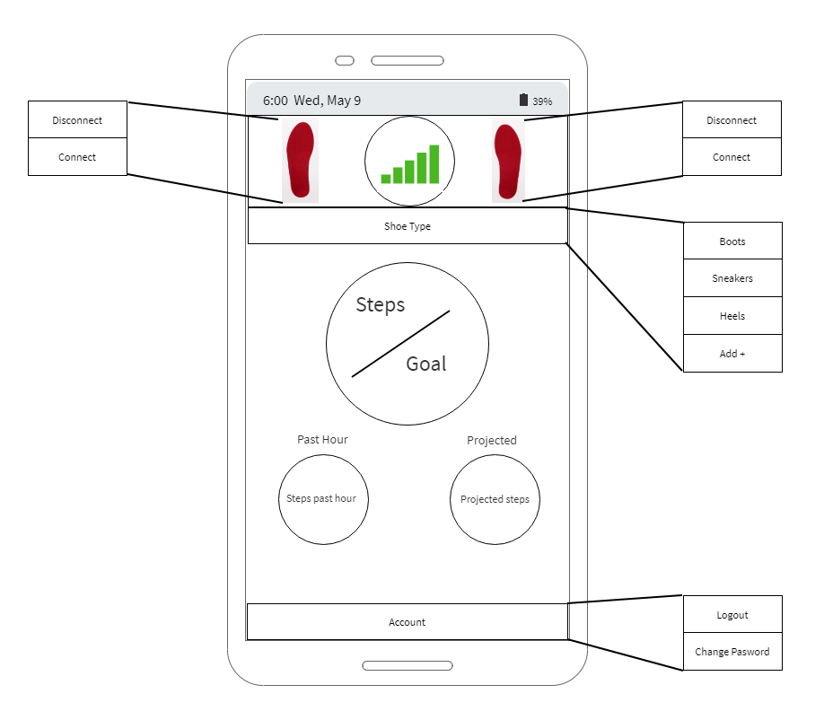

Figure 4 - Mockup of potential screen that could satisfy system requirements for showing simple connection statuses and user statistics.

Upon a successful login, the user should be able to view the screen shown above. The pop-outs shown are buttons that show options for each item selected. The app should be one page and allow the user to have a basic screen without a lot of clutter. The feet logos should either be green or red, depending on connection status to each insole.

## 4.3 Server to user

The last major interface between the LogiSteps system and the outside world is interaction that will occur between the web server and the user. The purpose of this interface is primarily to view and interact with user data that was generated from the insoles. While there is another user interface that will be available to users through their mobile device, the user interface that is served from the web server will provide more detailed analytics and provide a more complete experience. This interface will represent a bidirectional flow of information, presenting data to the user, while also accepting input related to authorization, navigation, and user account changes. This interface will represent several different view components, with their own requirements. These views, as well as the requirements for the interface will be defined in this section.

**Interface Requirements**

* The interface should provide a login screen to provide user authentication and protection of data.
* The interface should provide a method to create an account for users that have not been registered yet.
* The interface should not allow access to any application features until a user is authenticated.
* The interface should navigate a user to a main landing page upon successful authentication which will display a summary of user data from the past two days.
* The interface should provide a settings icon which will allow a user to change profile settings and logout of the application.
* The interface should provide a section for the user’s data, global data, and a connections tab which may be implemented in future version of the product.
* The interface should provide a list of tabs on the left-hand portion of the interface to navigate between different statistical analysis pages and graphics.
* The interface should present statistical analysis and graphics pages for recent activity, steps over time, steps by weekday, activity levels by week, pressure, and a map view of the user’s activity.
* The interface should protect user data during communications using HTTPS to encrypt data over the internet.

The specific statistical analysis and graphics pages each have their own set of requirements as well, which can be grouped better by identifying them on a feature by feature basis. A few wireframe mockups have been provided to illustrate what a view that fulfills the requirements may look like. Note that not all views have been mocked, but an implementation of the view should still fulfill its defined requirements.

**Login Screen**

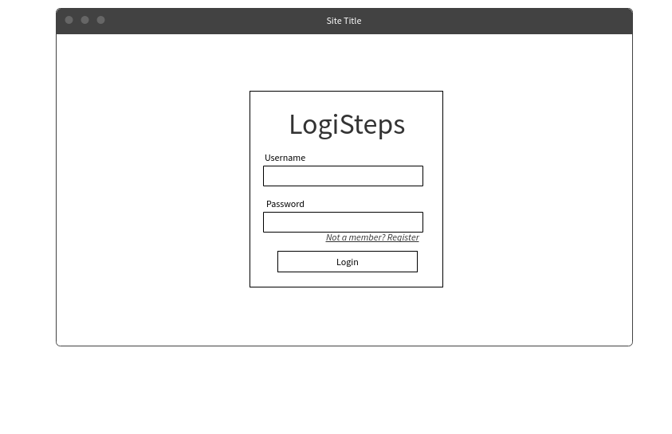

Figure 5 - Potential login screen that could meet system requirements for securing user data on the web platform.

The login screen is required to provide fields for providing user authentication using a username and password. Additionally, the login page must provide a link for registering a new user. This page must be the only page presented to a user until a successful user authentication entering a correct username and password and logging in.

**Main Page/Recent Tab**

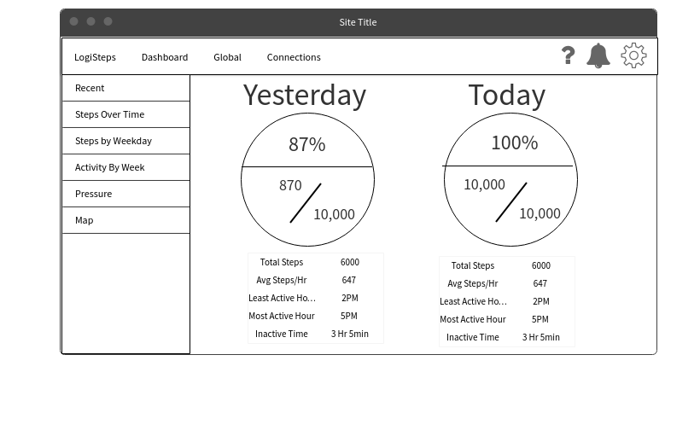

Figure 6 - Potential view that could satisfy the requirements for a main landing page and recent activity tab.

After a successful login attempt, the web application must navigate a user to a view displaying a summary of their past two days of activity. The minimum requirements of this view are:

* The view must display a user’s goal completion status for the current day and the previous day.
* The view must display a user’s step count against their goal for the current day and the previous day near the goal completion status.
* The goal completion status and steps vs goal visuals must be the dominating visual on the view.
* A summary of supporting statistics such as step total, average steps per hour, least active hour, most active hour, and inactive time must be displayed under the primary visuals.

**Steps over Time Tab**

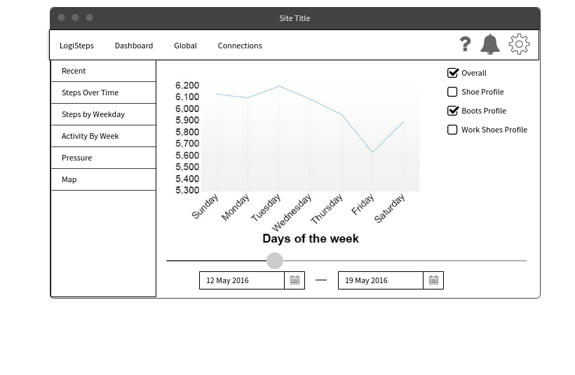

Figure 7 - Potential view that could satisfy the requirements for a steps over time page.

Upon navigating to the steps over time page, a user should be greeted with a visual representation of their steps over time. The type of graphical representation is not specified but must meet the criteria for the view.

* The view must display the number of steps taken in a day over the timespan of a week.
* The view must provide a means for viewing and selecting other weeks to view.
* The view must allow users to select different profiles in the case that they have multiple shoes using the LogiSteps technology.

**Steps by Weekday**

When a user navigates to the “Steps by Weekday” tab they should be presented with a view that summarizes their total step count over the past 6 months broken down by day of the week. For a view to satisfy this requirement, it must meet the following requirements.

* A graph must be shown which presents days of the week on the x-axis and total step count on the y-axis.
* All of the step data for a user should be used when displaying step count.

**Activity by Week**

The “activity by week” view should present a user with a summary of their activity vs. inactivity statistics for a given week. To meet this requirement, the view must meet the following criteria

* A user should be presented with a graphic for each of the seven days of the week.
* Each graphic for a day of the week should visually present active time percentage against inactive time percentage (such as stacked bar charts, pie charts).
* A user must be able to select different weeks to display data for.

**Pressure**

The pressure tab should present a view which will summarize the pressure statistics for a user’s feet while using the LogiSteps system. This view should provide a means of viewing changes over time that could result from changes in posture and fitness. To satisfy this requirement, the view must meet the following criteria

* Present a graphical visualization of a user’s pressure they place on certain parts of their feet using a heatmap placed over an image of an insole.
* The view should show data for the past day, past week, and past month to communicate changes in behavior.
* Each heatmap should use an aggregation of the data collected during the timespan that is being conveyed.

**Map**

The map tab should use GPS data to visualize a user’s step data by geographical area. To satisfy this requirement, the view should satisfy the following criteria.

* The view should use a map library, such as Google Maps, to display a map behind any data points.
* Steps should be plotted on the Map to convey a user’s geographic movement.
* Only a single day of step data should be shown at once.
* A filter should be implemented to allow users to select data for different days.